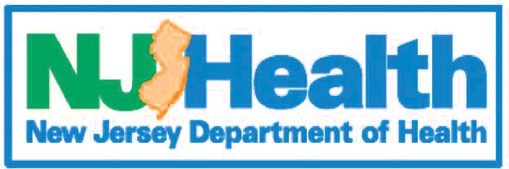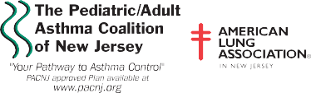Asthma Treatment Plan – Student
Sponsored by
(This asthma action plan meets NJ Law N.J.S.A. 18A:40-12.8) (Physician’s Orders)

(Please Print)

Name |  | Date of Birth |  | Effective Date
Doctor  Phone | Parent/Guardian (if applicable)  Phone |  | Emergency Contact  Phone

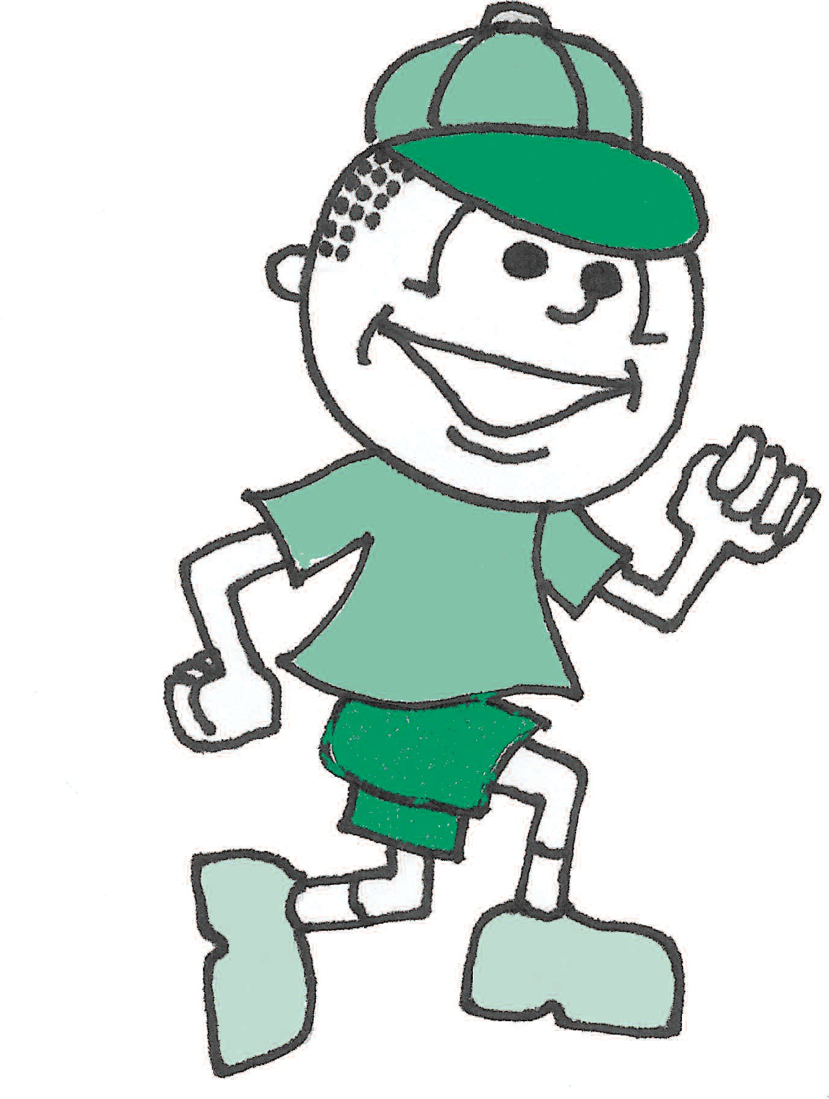
HEALTHY (Green Zone) ➠
MEDICINE
Take daily control medicine(s). Some inhalers may be more effective with a “spacer” – use if directed.
You have all of these:
- Breathing is good
- No cough or wheeze
- Sleep through the night
- Can work, exercise, and play

And/or Peak flow above

HOW MUCH to take and HOW OFTEN to take it

Remember to rinse your mouth after taking inhaled medicine.
- Advair® HFA □ 45, □ 115, □ 230 2 puffs twice a day
- AerospanTM □ 1, □ 2 puffs twice a day
- Alvesco® □ 80, □ 160 □ 1, □ 2 puffs twice a day
- Dulera® □ 100, □ 200 2 puffs twice a day
- Flovent® □ 44, □ 110, □ 220 2 puffs twice a day
- Qvar® □ 40, □ 80 □ 1, □ 2 puffs twice a day
- Symbicort® □ 80, □ 160 □ 1, □ 2 puffs twice a day
- Advair Diskus® □ 100, □ 250, □ 500 1 inhalation twice a day
- Asmanex® Twisthaler® □ 110, □ 220 □ 1, □ 2 inhalations □ once or □ twice a day
- Flovent® Diskus® □ 50 □ 100 □ 250 1 inhalation twice a day
- Pulmicort Flexhaler® □ 90, □ 180 □ 1, □ 2 inhalations □ once or □ twice a day
- Pulmicort Respules® (Budesonide) □ 0.25, □ 0.5, □ 1.0 1 unit nebulized □ once or □ twice a day
- Singulair® (Montelukast) □ 4, □ 5, □ 10 mg 1 tablet daily
- Other
- None
Triggers
Check all items that trigger patient’s asthma:
- Colds/flu
- Exercise
- Allergens
  - Dust Mites, dust, stuffed animals, carpet
  - Pollen - trees, grass, weeds
  - Mold
  - Pets - animal dander
  - Pests - rodents, cockroaches
- Odors (Irritants)
  - Cigarette smoke & second hand smoke

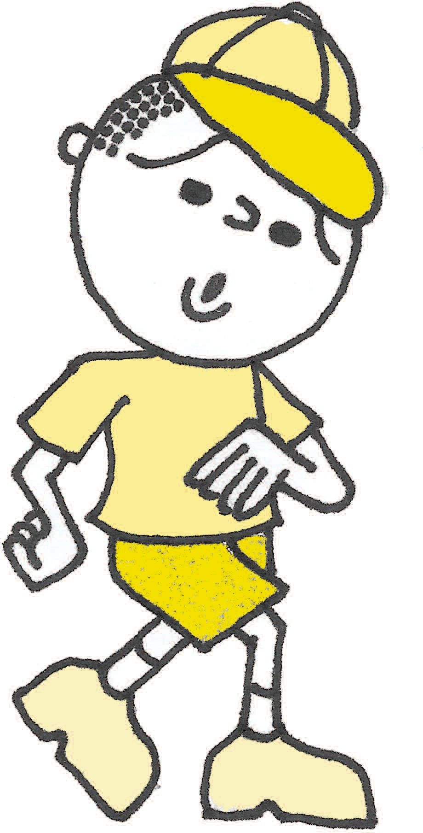 If exercise triggers your asthma, take puff(s) minutes before exercise.
You have any of these:
- Cough
- Mild wheeze
- Tight chest
- Coughing at night
- Other:
If quick-relief medicine does not help within 15-20 minutes or has been used more than 2 times and symptoms persist, call your doctor or go to the emergency room.
EMERGENCY (Red Zone) ➠
And/or Peak flow from to
Your asthma is
- Albuterol MDI (Pro-air® or Proventil® or Ventolin®) _2 puffs every 4 hours as needed
- Xopenex® 2 puffs every 4 hours as needed
- Albuterol □ 1.25, □ 2.5 mg 1 unit nebulized every 4 hours as needed
- Duoneb® 1 unit nebulized every 4 hours as needed
- Xopenex® (Levalbuterol) □ 0.31, □ 0.63, □ 1.25 mg _1 unit nebulized every 4 hours as needed
- Combivent Respimat® 1 inhalation 4 times a day
- Increase the dose of, or add:
- Other
- If quick-relief medicine is needed more than 2 times a week, except before exercise, then call your doctor.
HOW MUCH to take and HOW OFTEN to take it
MEDICINE
Continue daily control medicine(s) and ADD quick-relief medicine(s).
Take these medicines NOW and CALL 911.
Asthma can be a life-threatening illness. Do not wait!
MEDICINE HOW MUCH to take and HOW OFTEN to take it
- Albuterol MDI (Pro-air® or Proventil® or Ventolin®) _ 4 puffs every 20 minutes
- Xopenex® 4 puffs every 20 minutes
- Albuterol □ 1.25, □ 2.5 mg 1 unit nebulized every 20 minutes
- Duoneb® 1 unit nebulized every 20 minutes
- Xopenex® (Levalbuterol) □ 0.31, □ 0.63, □ 1.25 mg 1 unit nebulized every 20 minutes
- Combivent Respimat® 1 inhalation 4 times a day
- Other

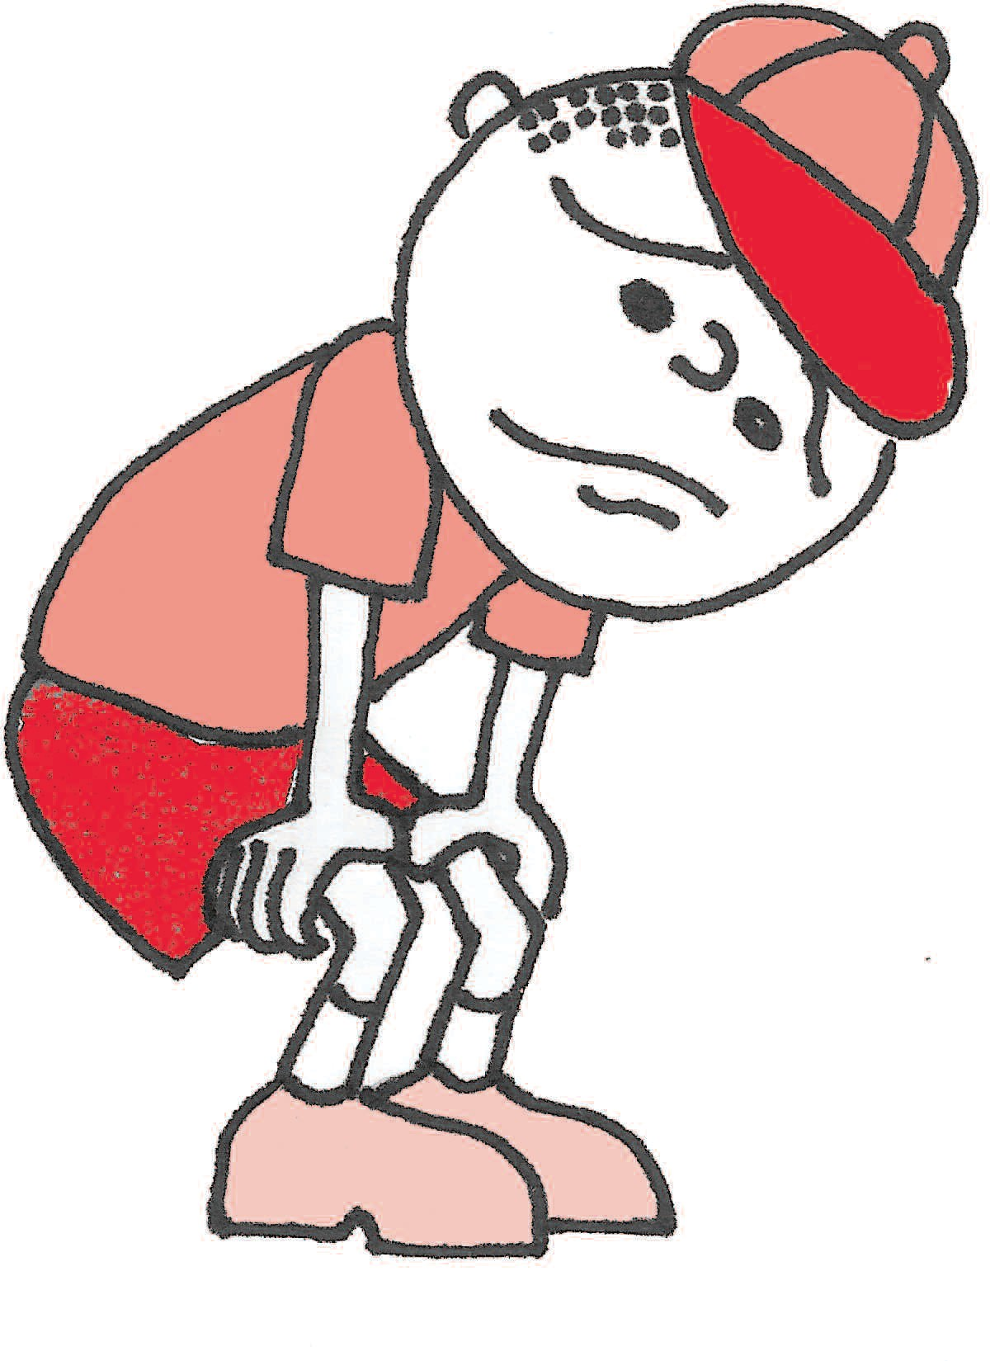
getting worse fast:
    - Quick-relief medicine did
not help within 15-20 minutes
    - Breathing is hard or fast
    - Nose opens wide • Ribs show
    - Trouble walking and talking
  - Perfumes, cleaning products, scented products
  - Smoke from burning wood, inside or outside
- Weather
  - Sudden temperature change
  - Extreme weather
- hot and cold
  - Ozone alert days
- Foods:

- Other:

This asthma treatment plan is meant to assist, not replace, the clinical

And/or Peak flow
  - Lips blue • Fingernails blue
  - Other:
decision-making required to meet

below
individual patient needs.

Disclaimers: The use of this Website/PACNJ Asthma Treatment Plan and its content is at your own risk. The content is provided on an “as is” basis. The American Lung Association of the Mid-Atlantic (ALAM-A), the Pediatric/Adult Asthma Coalition of New Jersey and all affiliates disclaim all warranties, express or implied, statutory or otherwise, including but not limited to the implied warranties or merchantability, non-infringement of third parties’ rights, and fitness for a particular purpose. ALAM-A makes no representations or warranties about the accuracy, reliability, completeness, currency, or timeliness of the content. ALAM-A makes no warranty, representation or guaranty that the information will be uninterrupted or error free or that any defects can be corrected. In no event shall ALAM-A be liable for any damages (including, without limitation, incidental and consequential damages, personal injury/wrongful death, lost profits, or damages resulting from data or business interruption) resulting from the use or inability to use the content of this Asthma Treatment Plan whether based on warranty, contract, tort or any other legal theory, and whether or not ALAM-A is advised of the possibility of such damages. ALAM-A and its affiliates are not liable for any claim, whatsoever, caused by your use or misuse of the Asthma Treatment Plan, nor of this website.
The Pediatric/Adult Asthma Coalition of New Jersey, sponsored by the American Lung Association in New Jersey. This publication was supported by a grant from the New Jersey Department of Health and Senior Services, with funds provided by the U.S. Centers for Disease Control and Prevention under Cooperative Agreement 5U59EH000491-5. Its contents are solely the responsibility of the authors and do not necessarily represent the official views of the New Jersey Department of Health and Senior Services or the
U.S. Centers for Disease Control and Prevention. Although this document has been funded wholly or in part by the United States Environmental Protection Agency under Agreement XA96296601-2 to the American Lung Association in New Jersey, it has not gone through the Agency’s publications review process and therefore, may not necessarily reflect the views of the Agency and no official endorsement should be inferred. Information in this publication is not intended to diagnose health problems or take the place of medical advice. For asthma or any medical condition, seek medical advice from your child’s or your health care professional.
Permission to Self-administer Medication:
- This student is capable and has been instructed in the proper method of self-administering of the non-nebulized inhaled medications named above in accordance with NJ Law.
- This student is not approved to self-medicate.
PHYSICIAN/APN/PA SIGNATURE DATE
Physician’s Orders
PARENT/GUARDIAN SIGNATURE
PHYSICIAN STAMP

REVISED AUGUST 2014
Permission to reproduce blank form • www.pacnj.org
Make a copy for parent and for physician file, send original to school nurse or child care provider.

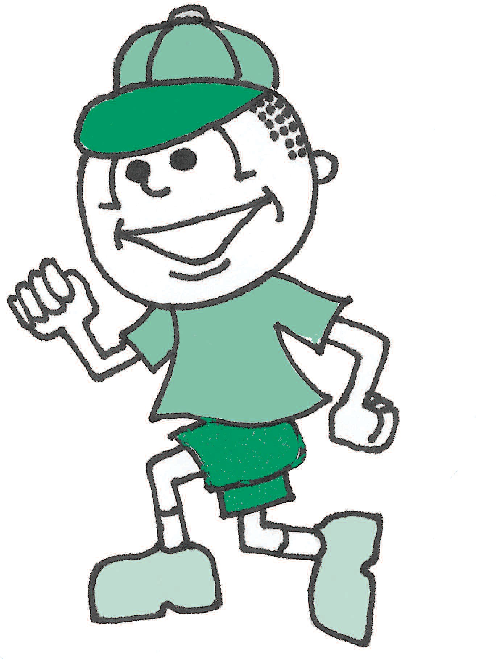
Asthma Treatment Plan – Student Parent Instructions
The PACNJ Asthma Treatment Plan is designed to help everyone understand the steps necessary for the individual student to achieve the goal of controlled asthma.
    - Parents/Guardians: Before taking this form to your Health Care Provider, complete the top left section with:
      - Child’s name • Child’s doctor’s name & phone number • Parent/Guardian’s name
      - Child’s date of birth • An Emergency Contact person’s name & phone number & phone number
    - Your Health Care Provider will complete the following areas:
      - The effective date of this plan
      - The medicine information for the Healthy, Caution and Emergency sections
      - Your Health Care Provider will check the box next to the medication and check how much and how often to take it
      - Your Health Care Provider may check “OTHER” and:

v Write in asthma medications not listed on the form
v Write in additional medications that will control your asthma
v Write in generic medications in place of the name brand on the form
      - Together you and your Health Care Provider will decide what asthma treatment is best for your child to follow
    - Parents/Guardians & Health Care Providers together will discuss and then complete the following areas:
      - Child’s peak flow range in the Healthy, Caution and Emergency sections on the left side of the form
      - Child’s asthma triggers on the right side of the form
      - Permission to Self-administer Medication section at the bottom of the form: Discuss your child’s ability to self-administer the inhaled medications, check the appropriate box, and then both you and your Health Care Provider must sign and date the form
    - Parents/Guardians: After completing the form with your Health Care Provider:
      - Make copies of the Asthma Treatment Plan and give the signed original to your child’s school nurse or child care provider
      - Keep a copy easily available at home to help manage your child’s asthma
      - Give copies of the Asthma Treatment Plan to everyone who provides care for your child, for example: babysitters, before/after school program staff, coaches, scout leaders

PARENT AUTHORIZATION
I hereby give permission for my child to receive medication at school as prescribed in the Asthma Treatment Plan. Medication must be provided in its original prescription container properly labeled by a pharmacist or physician. I also give permission for the release and exchange of information between the school nurse and my child’s health care provider concerning my child’s health and medications. In addition, I understand that this information will be shared with school staff on a need to know basis.

Parent/Guardian Signature Phone Date

FILL OUT THE SECTION BELOW ONLY IF YOUR HEALTH CARE PROVIDER CHECKED PERMISSION FOR YOUR CHILD TO SELF-ADMINISTER ASTHMA MEDICATION ON THE FRONT OF THIS FORM.
RECOMMENDATIONS ARE EFFECTIVE FOR ONE (1) SCHOOL YEAR ONLY AND MUST BE RENEWED ANNUALLY
- I do request that my child be ALLOWED to carry the following medication for self-administration in school pursuant to N.J.A.C:.6A:16-2.3. I give permission for my child to self-administer medication, as prescribed in this Asthma Treatment Plan for the current school year as I consider him/her to be responsible and capable of transporting, storing and self-administration of the medication. Medication must be kept in its original prescription container. I understand that the school district, agents and its employees shall incur no liability as a result of any condition or injury arising from the self-administration by the student of the medication prescribed on this form. I indemnify and hold harmless the School District, its agents and employees against any claims arising out of self-administration or lack of administration of this medication by the student.
- I DO NOT request that my child self-administer his/her asthma medication.

Parent/Guardian Signature Phone Date

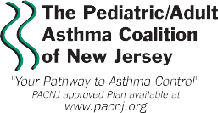
Disclaimers: The use of this Website/PACNJ Asthma Treatment Plan and its content is at your own risk. The content is provided on an “as is” basis. The American Lung Association of the Mid-Atlantic (ALAM-A), the Pediatric/Adult Asthma Coalition of New Jersey and all affiliates disclaim all warranties, express or implied, statutory or otherwise, including but not limited to the implied warranties or merchantability, non-infringement of third parties’ rights, and fitness for a particular purpose. ALAM-A makes no representations or warranties about the accuracy, reliability, completeness, currency, or timeliness of the content. ALAM-A makes no warranty, representation or guaranty that the in- formation will be uninterrupted or error free or that any defects can be corrected. In no event shall ALAM-A be liable for any damages (including, without limitation, incidental and consequential damages, personal injury/wrongful death, lost profits, or damages resulting from data or business interruption) resulting from the use or inability to use the content of this Asthma Treatment Plan whether based on warranty, contract, tort or any other legal theory, and whether or not ALAM-A is advised of the possibility of such damages. ALAM-A and its affiliates are not liable for any claim, whatsoever, caused by your use or misuse of the Asthma Treatment Plan, nor of this website.
The Pediatric/Adult Asthma Coalition of New Jersey, sponsored by the American Lung Association in New Jersey. This publication was supported by a grant from the New Jersey Department of Health and Senior Services, with funds provided by the U.S. Centers for Disease Control and Prevention under Cooperative Agreement 5U59EH000491-5. Its content are solely the responsibility of the authors and do not necessarily represent the official views of the New Jersey Department of Health and Senior Services or the U.S. Centers for Disease Control and Prevention. Although this document has been funded wholly or in part by the United States Environmental Protection Agency under Agreement XA96296601-2 to the American Lung Association in New Jersey, it has not gone through the Agency’s publications review process and therefore, may not necessarily reflect the views of the Agency and no official endorsement should be inferred. Information in this publication is not intended to diagnose health problems or take the place of medical advice. For asthma or any medical condition, seek medical advice from your child’s or your health care professional.
Sponsored by

